ATTRITION PROJECT
Inference
from the Decision Tree
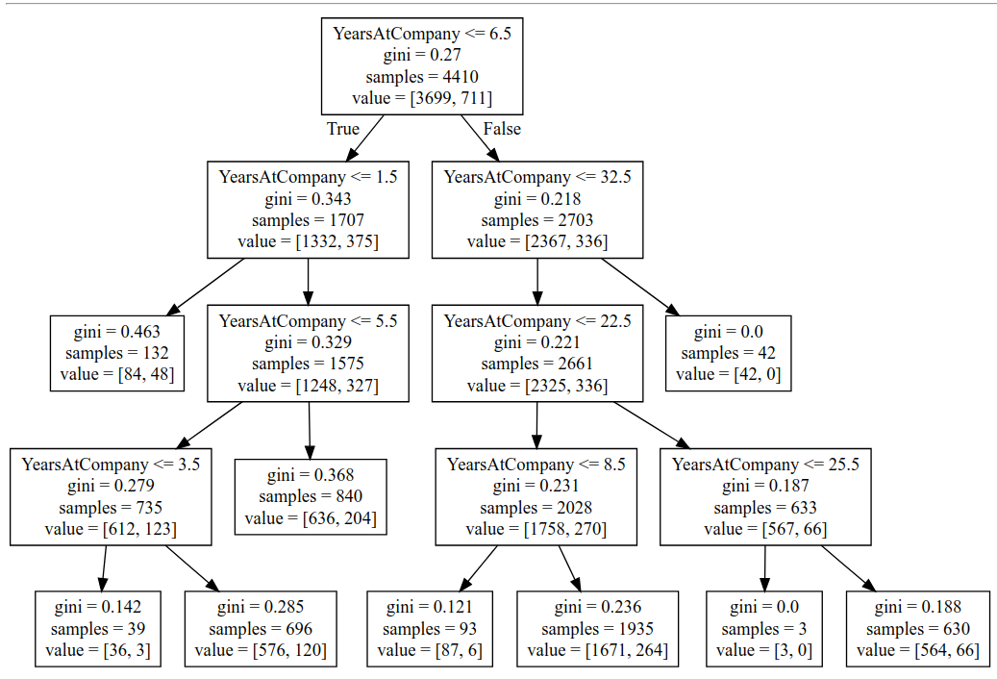
- If the yearsatcompany<6.5 , the people who are removed or the cases where attrition happens is 3699 and people who are remained is 711.
- Above class is further subdivided into if the yearsatcompany<=1.5 then the people who are removed from the office are 1332 and 375 are kept.
- Then further if the yearsatcompany=1 then ppl who are removed are 84 and 48 are kept further subset for yearsatcompany<=5.5 then ppl who are removed are 1248 and 327 are kept in the company this further is subdivided into two more category of for yrs<=3.5 and in that category 612 are removed and 123 are kept in the company.
- For yrsatcompany<=32.5 then it can further divided into for yrs>=32.5 42 ppl are removed and 0 are kept and years <=22.5 2325 are kept and 336 are removed.
- For yrsatcompany<=8.5 the ppl who are removed are characterized in two samples 1758 and 270 . out of 1758 87 are removed for less than 8.5 yrs of work at company and 1671 are removed for work greater than 8.5 yrs.
- For yrsatcompany>8.5 but <=25 yrs 567 ppl are removed from the company and 66 are kept out of these for workatcompany<25.5, 564 ppl are removed and for yrs at company<25.5, 3 ppl are removed.

